SQL queries Doc

Level 0 - Data Validation

Q1. Total Loans
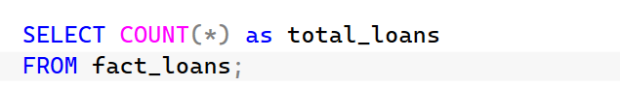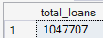

Q2. Loan Status Distribution
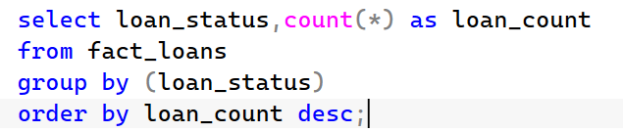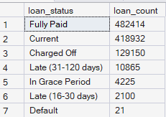

Q3. Loan Outcome Distribution
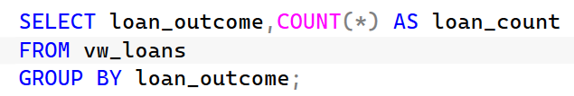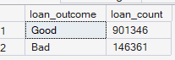

Level 1 - Portfolio KPIs

Q4. Total Loan Amount Issued
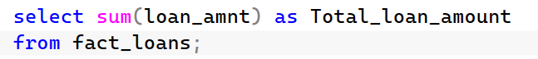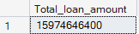

Q5. Average Loan Amount
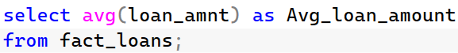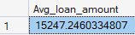

Q6. Average Interest Rate
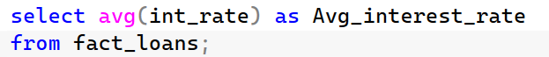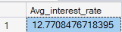

Q7. Average Borrower Income
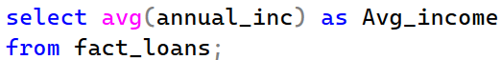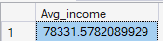

Q8. Overall Default Rate
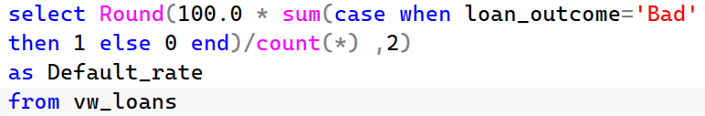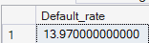

Level 2 - Risk Driver Analysis
Q9. Default Rate by Grade
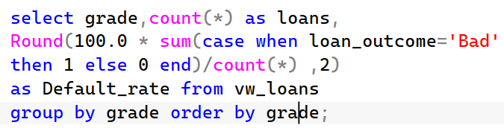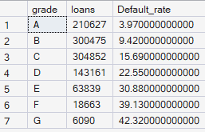

Q10. Default Rate by Purpose
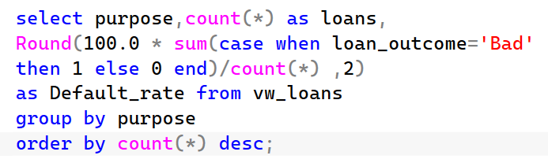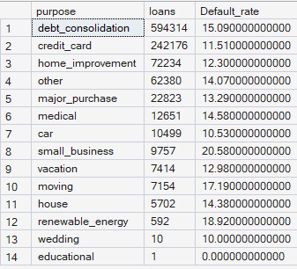

Q11. Default Rate by Home Ownership
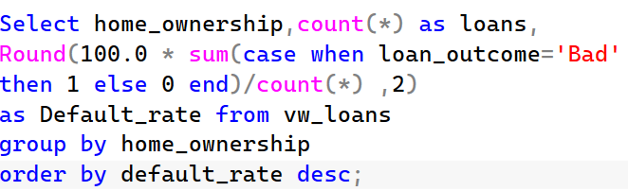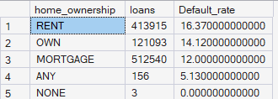

Q12. Default Rate by Verification Status
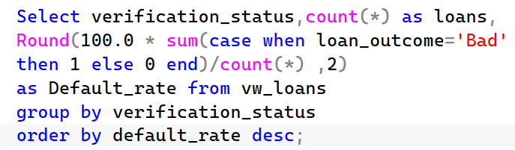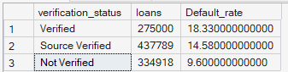

Level 3 - Numerical Driver Analysis
Q13. Average FICO by Outcome
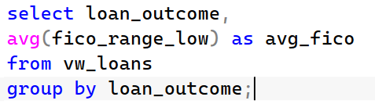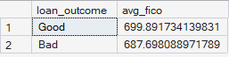

Q14. Average DTI by Outcome
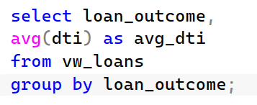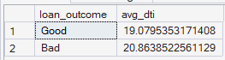

Q15. Average Income by Outcome
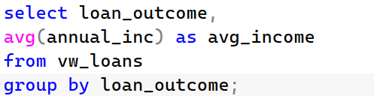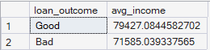

Q16. Average Interest Rate by Outcome
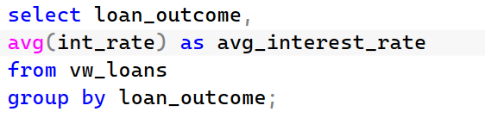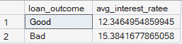

Level 4 - Time Analysis
Q17. Loan Volume by Year
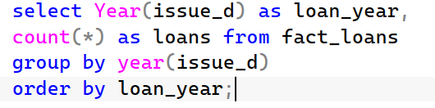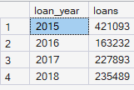

Q18. Default Rate by Year
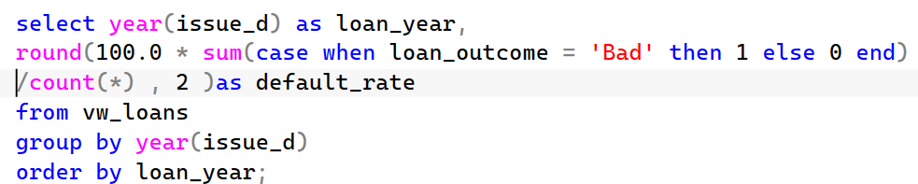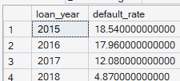

Level 5 - Geographic Analysis
Q19. Top States by Loan Volume
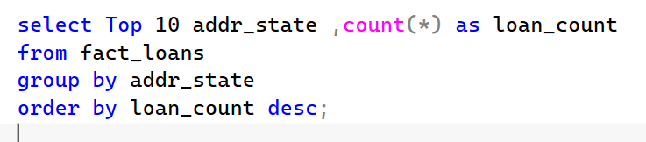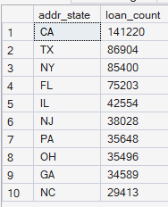

Q20. Highest Default States
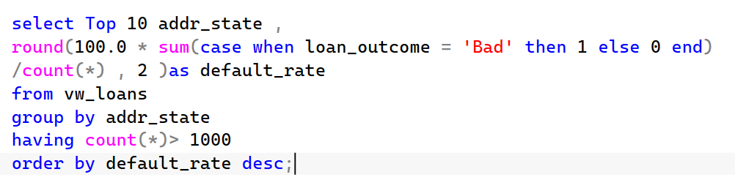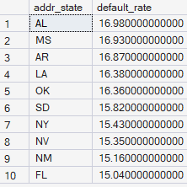

Level 6 - Intermediate SQL
Q21. Rank Purposes by Default Rate
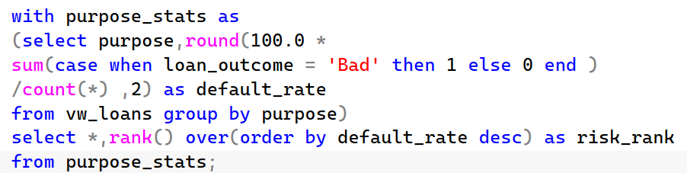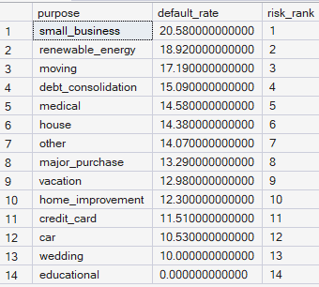

Q22. Rank States by Default Rate
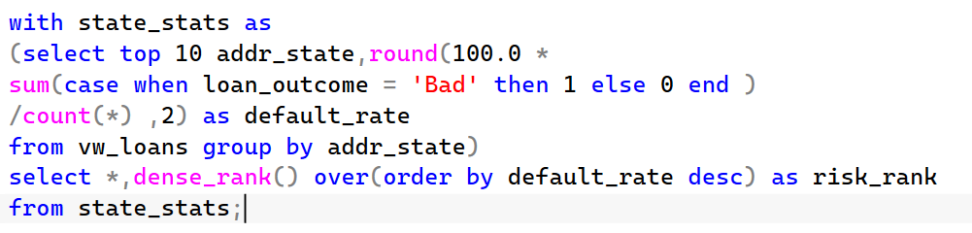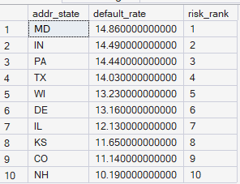

Level 7 - Advanced SQL
Q23. Risk Segmentation
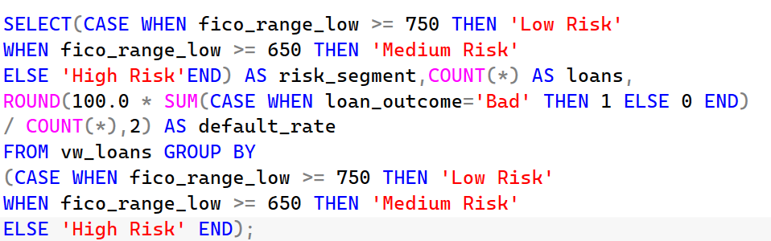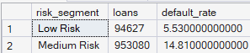

Q24. Income Segmentation
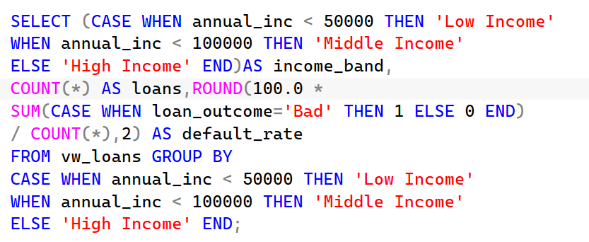
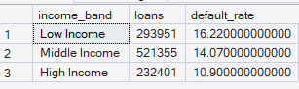

Level 8 - Dashboard KPI Views
vw_portfolio_kpis
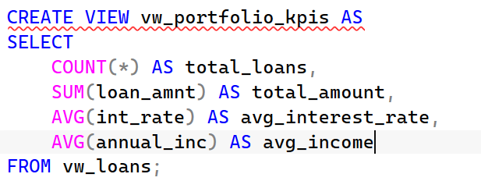

vw_default_by_grade
